Avoiding Zoom-bombing in online sessions
With everyone utilizing zoom for remote teaching, it is becoming increasing important that we utilize the security tools within zoom to mitigate disruptions during online sessions.
The following suggestions will help you to ensure that only your students can join your session and prevent hijacking of your class, currently known as zoom bombing.

Some important information on how Zoom works:
Zoom is an app for your phone or computer that can be accessed in a variety of ways, directly by opening the app, through the Zoom or ConferZoom websites, or through the canvas integration. All options are gateways to opening the app on your device (computer, tablet, phone). Once you are in a zoom session, it is much like being on a website, only what is shared by the host is visible to the participants. No other personal data is exchanged in a session.

Tips to Prevent “Zoom-bombing” during meeting SCHEDULING:

Do not schedule sessions using the canvas ConferZoom feature
Schedule sessions through the ConferZoom.org website or the zoom app on your computer to allow for additional security features that are not available when scheduling through the ConferZoom feature in the navigation menu of your canvas course, such as using a password.

Do not use Personal ID for sessions
Your personal ID stays the same, so if you use this for class sessions anyone with the ID can join you in any of your sessions. Ensure this is toggled off in your account settings on the ConferZoom.org website.

Use a password for sessions
When you schedule a zoom session via ConferZoom.org (rather than through canvas), one of the options is to require a password. Doing this will prevent someone from randomly guessing your meeting ID and joining your session. This is how most zoom bombers are initially getting access to sessions. You can then provide students a one-click join option by putting the link in your canvas page.

Utilize the waiting room
The waiting room allows you to admit students individually or as a group when class begins and prevent individuals from joining later without permission.

Ensure you have the most recent version of the Zoom app
Version 4.6.7 is the most recent version. You can view which version you have when the app initially opens.
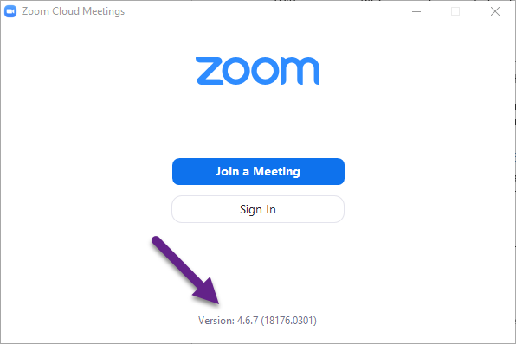

Set participants as muted and video off at meeting start
When setting up meetings, select Mute participants upon entry and start with video off.

Do not allow removed participates to rejoin
Toggle off the setting that allows participates to rejoin if they are removed by the host. If a disruptive student is removed, they will not be able to rejoin the session.

Ensure that you are not allowing remote control during screen sharing
Toggle off the remote control while sharing option to prevent accidently allowing participant’s access to hosts screen.

Consider using meeting registration (only available if scheduling via ConferZoom.org)
Meeting registration requires attendees to register their name and email address prior to being emailed a link to join the session. This is the only way to require attendees to provide an email address to the host.

Recommended settings if scheduling from ConferZoom.org and the Zoom App
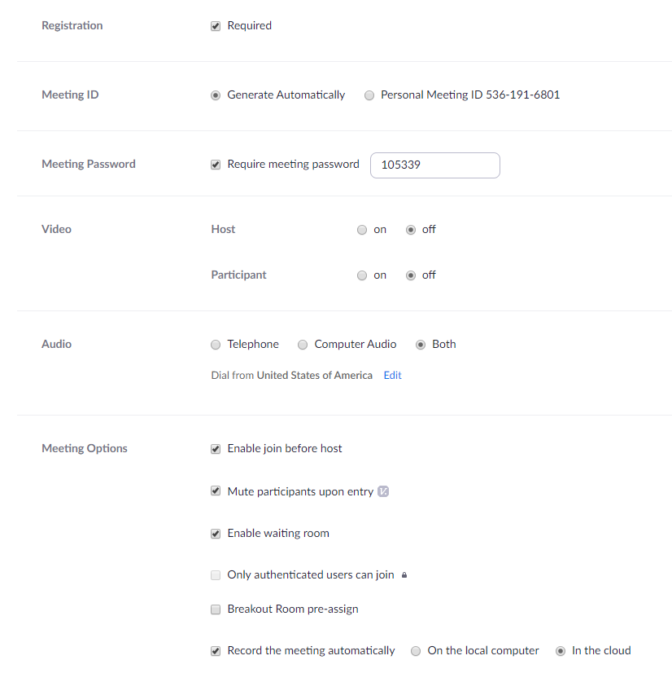
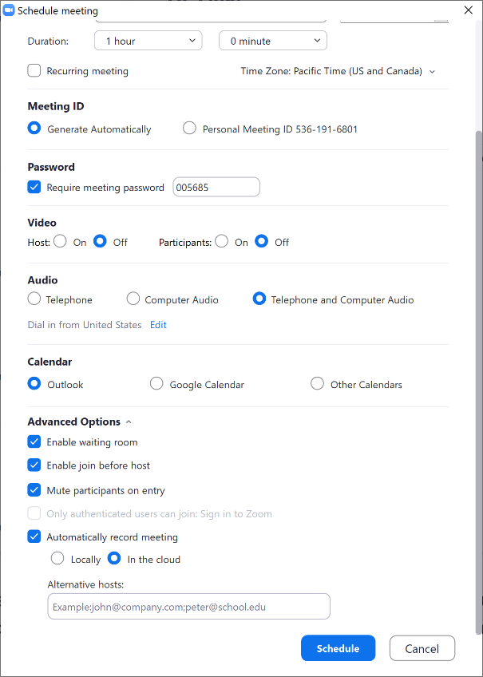
Zoom App settings
Conferzoom.org settings

Tips to reduce disturbances DURING SESSIONS

Manage participants options
Do not allow participants to Unmute or Rename themselves. This menu is accessed by selecting “manage participants” in the zoom app and then selecting “more” at the bottom of the participants window.

Consider locking the meeting after a certain amount of time
This will prevent individuals joining after meeting is locked. Pro: This prevents individuals from randomly joining late if they discover your session ID after the session begins. Con: students cannot join the session late or rejoin if they have a technology problem.
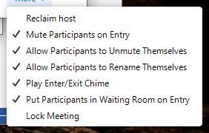

Consider turning off the participant screen sharing
The host can turn participant screen sharing off by default in the settings on ConferZoom.org prior to scheduling and/or choose to allow participant sharing during a live session.
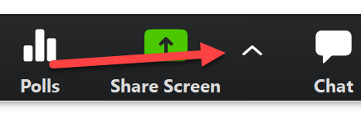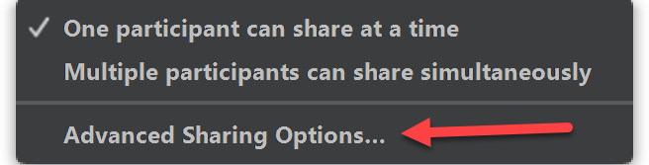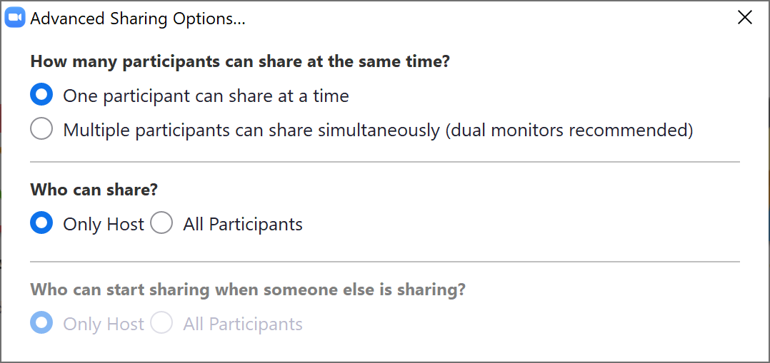

Consider turning off annotations by participants
Annotations allow participants to write on the screen. This feature can be disabled during the session while in screenshare mode.
